EXPERIMNET 03

- Select employees with salaries greater than 7000.
CREATE TABLE Employee__56 (Emp_id int PRIMARY KEY ,Emp_name varchar(30),Dept varchar(30),Salary int);
INSERT INTO Employee__56 (Emp_id,Emp_name,Dept,Salary)values(1,'David Smith','HR',5000);
INSERT INTO Employee__56 (Emp_id,Emp_name,Dept,Salary)values(2,'Oiler','Marketing',4500);
INSERT INTO Employee__56 (Emp_id,Emp_name,Dept,Salary)values(3,'Clara','Production',6000);
INSERT INTO Employee__56 (Emp_id,Emp_name,Dept,Salary)values(4,'Arunima','Sales',7000);
SELECT * FROM Employee__56 WHERE Salary>7000;

Output :

- Update the salary of 'David Smith' to 8200.00.

UPDATE Employee__56 SET Salary=8200 WHERE Emp_id=1;
SELECT * FROM Employee__56;

Output :

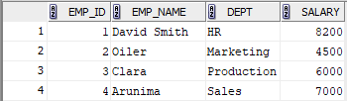

- Insert a new employee with Emp_id = 6, Emp_name = 'Daniel Harris', Dept = 'Production', and Salary = 6700.00.

INSERT INTO Employee__56 (Emp_id,Emp_name,Dept,Salary)values(6,'Daniel Harris','Production',6700);
SELECT * FROM Employee__56;

Output :

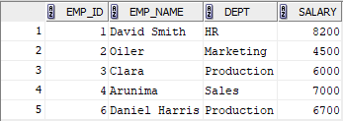

- Delete the employee with Emp_id = 3 ('Charles Brown').

DELETE FROM Employee__56 WHERE Emp_id=3;
SELECT * FROM Employee__56;

Output :

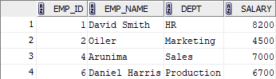

- Select employees whose names do not start with 'D' or 'O.'

SELECT Emp_name FROM Employee__56 WHERE Emp_name NOT LIKE 'D%' AND Emp_name NOT LIKE 'o%';

Output :

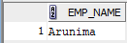

- Calculate the total salary expense for each department.

SELECT Dept,SUM(Salary) as tot_Salary FROM Employee__56 GROUP BY Dept;
Output :
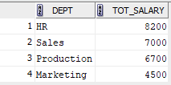
- Update the salary of employees in the 'Production' department by adding 5% to their current salaries.

UPDATE Employee__56 SET SALARY=SALARY+(SALARY*0.05)WHERE Dept='Production';

Output :

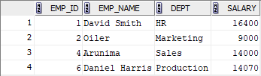

- Delete all employees with salaries below 7000.

DELETE FROM Employee_56 WHERE SALARY<7000;

OUTPUT :

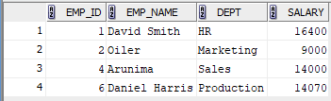

- Find the employee with the lowest salary and display their name and salary.

SELECT EMP_NAME,SALARY FROM Employee__56 WHERE SALARY=(SELECT MIN(SALARY)FROM Employee__56);

Output :

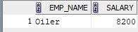

- Update the salary of employees in the 'Marketing' department to 8200.00.

Update Employee__56 set SALARY=8200 where DEPT='Marketing';

Output :

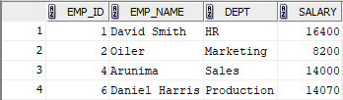

- Find the names of all employees starting with the alphabet 'A':

SELECT EMP_NAME FROM Employee__56 where EMP_NAME LIKE 'A%';

Output :

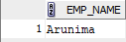

- List the names of all employees whose empname contains the substring 'it':

SELECT * FROM Employee__56 WHERE UPPER(Emp_name)LIKE '%it%';

Output :

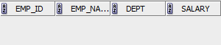
- List all departments in Upper Case Format

SELECT UPPER(Dept)FROM Employee__56;

Output :

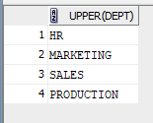

- List the employee details whose department starts with 'M', with the 3rd letter as 'r', and containing the substring 'ket':

SELECT * FROM Employee__56 WHERE UPPER(Dept)LIKE 'M_R%' AND UPPER(Dept) LIKE '%KET%';

Output :

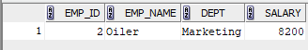

- List all departments in reverse in uppercase format (avoid duplicates)

SELECT distinct reverse(UPPER(Dept))FROM Employee__56;

Output :

